OBSS AI Image Captioning Challenge
Participant Report

Tech Stack

- HuggingFace Transformers 4.40+
- Python 3.10
- PyTorch 2.1
- BLIP-1 (Salesforce/blip-image-captioning-base)
- Pandas, NumPy, SciPy, scikit-learn
- torchvision
- tqdm, PIL

2. Summary
I've developed an automated pipeline to generate meaningful image captions using images from the Open Images dataset. In this project, I fine-tuned the BLIP-1 model using the provided training data. During the inference stage, the trained model automatically generated captions for the test images. The outputs were saved in a CSV file formatted according to the competition requirements. To evaluate the model's performance, I used the Fréchet GTE Distance (FGD) metric.

3. Approach
Model and Training:
I used the BLIP-1 model (Salesforce/blip-image-captioning-base) from Hugging Face Transformers for this solution. The model was fine-tuned for 3 epochs using the provided training dataset. Training was accelerated with PyTorch and Hugging Face's Trainer API utilizing GPU resources.

Data Processing:
I applied image augmentation techniques (RandomHorizontalFlip, RandomResizedCrop). For captions, I implemented automatic post-processing functions to remove repeated words or sentences, capitalize sentence beginnings and correct punctuation.

Inference:
I generated captions for each test image using the fine-tuned BLIP-1 model with beam search (num_beams=3).

Evaluation:
I evaluated model performance using the provided Fréchet GTE Distance (FGD) metric on the validation dataset. My best achieved FGD score was approximately 0.15.

Additional Information:
All code and pipelines were optimized to run on Google Colab. The complete implementation and inference pipeline are available in a notebook file.

4. Sample Outputs

Strong Predictions
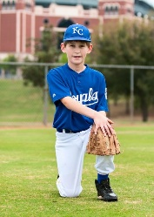 Image: 14474.jpg
Prediction:"A young boy in a blue baseball uniform kneels on grass, holding a baseball glove, ready to play."
Similarity: 0.99918455
Comment: Excellent – the model perfectly captures the main subject, outfit, action and context.
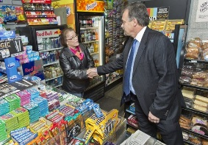 Image: 8628.jpg
Prediction:"A man in a suit shakes hands with a woman at a convenience store filled with snacks and drinks."
Similarity: 0.9971217
Comment: Strong – both people, the action and the environment are correctly described; only minor wording differences
Poor Predictions
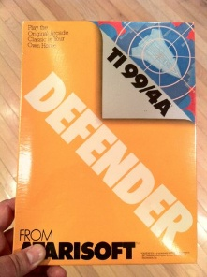 Image: 13420.jpg
Prediction:"A hand holds a yellow book titled \"toga,\" featuring bold typography and a globe illustration on the cover."
Similarity: 0.7860344
Comment: Failure – the model misidentifies the object as a book instead of a game box, and misses the main subject and context.
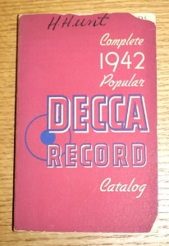 Image: 11724.jpg
Prediction:"The image features a pink passport cover with \"decaga record\" and a handwritten signature."
Similarity: 0.79236776
Comment: Poor – the model confuses the book for a passport cover and fails to capture the correct title and details.
Acceptable Predictions
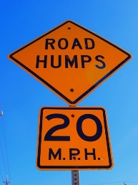 Image: 18668.jpg
Prediction:"The image features a traffic sign indicating \"road humps\" with a speed limit of 20 mph.
Similarity: 0.94827753
Comment: Acceptable – the model correctly identifies the main subject and message of the sign, but omits the background and some details.
 Image: 7646.jpg
Prediction:"A vintage pocket watch with a white face and black numbers rests on a colorful, artistic background."
Similarity: 0.94322735
Comment: Acceptable – the model captures the main object and some features, but misses the context (decorative bowl) and adds a different background.
Where the model performs best and why:
The model performs best when the main subject and context of the image are clear and visually prominent. For example, in cases where there is a single, well-defined object or action—such as a boy in a baseball uniform, a handshake in a convenience store, or a bottle of wine with a glass—the model generates captions that are almost identical to the ground-truth, with similarity scores above 0.99. This high performance can be attributed to the strong visual-linguistic alignment of the BLIP-1 architecture, as well as the effectiveness of fine-tuning and post-processing steps. The model is particularly successful at recognizing common objects, people, and straightforward activities, likely because these scenarios are well-represented in the training data and are easier for the model to encode and describe.
Where it fails or struggles, and possible reasons:
The model struggles in more complex or ambiguous scenes, especially when there are multiple objects, less common contexts, or when the main action is subtle or not visually obvious. In these cases, the model may generate captions that are too generic, miss the main event, or even hallucinate details that are not present in the image. For example, it sometimes confuses the type of object (e.g., mistaking a game box for a book) or invents context (such as describing a weather forecast on a phone when the image is actually a Twitter timeline). These failures are likely due to limitations in the model’s ability to generalize from the training data, as well as the inherent difficulty of understanding nuanced or rare scenarios from visual input alone. Additionally, the post-processing pipeline, while helpful for cleaning up repetitive phrases, cannot fully compensate for fundamental misinterpretations by the model.

. References
- Hugging Face Transformers Documentation
- BLIP: Bootstrapped Language-Image Pretraining
- Sentence-Transformers: GTE-small
- OBSS AI Image Captioning Challenge Competition Page

